MyEd BC Student Portal Guide
Please note the first time you log in it is recommended to use a computer or laptop.
After setup is completed, you can access your account from a mobile device.
☐ Login at https://www.myeducation.gov.bc.ca/aspen/logon.do
How to Login
☐ Enter your Login ID (student number)
☐ Enter your Password
- If you are new to Imagine High, you will be provided with a password. The first time you log in you will be prompted to enter an email address and change your password.
  - Enter your sd33online.ca email account (student#@sd33online.bc.ca)
  - Your password must contain special characters; you can click on the blue text “click to view” to see the specific requirements for the password.
Checking your Schedule

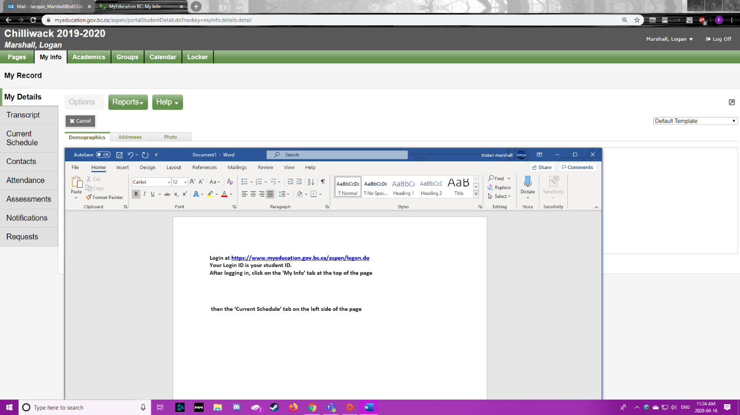
☐ Click on the ‘My Info’ tab at the top of the page.
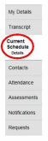
☐ Then click on Current Schedule.
Checking Your Grades
☐ Click on the Academics at the top of the page.
- Your classes will be listed in this window. The most recent grade in each course, for the current term will be in the blue highlighted area. (In the example shown below the grade is for term 4 (Q4 = quarter 4).
- Marks will only be shown for courses where the teacher has chosen to make the mark visible.
- If the grade is not visible and you would like to know how you are doing in that course, please see your teacher.
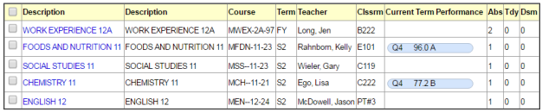
☐ For more detailed information on the mark displayed, click on the name of the class in the list and then click on the Assignments side-tab.
Checking Your Grades Continued
  - The assignments will be shown in a list, with percentages for each one listed.
  - If the teacher has included written feedback for the assignment in the program, these comments will be shown in the far right-hand column.
  - To go back and view the detailed mark for another class, click on the blue “Classes” link under the options menu in the top left-hand corner of the screen.
Accessing Learning Updates (previously known as Report Cards)
☐ You will land on the Pages top tab every time you log in.
☐ The main landing Page includes:
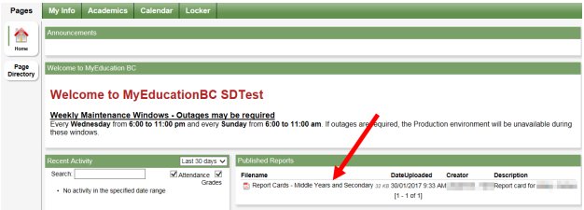
Published Reports - When a Learning Update is published to the portal, it will appear under the Published Reports heading as a hyperlinked PDF document. You will receive an email that it has been published to the portal.

On a mobile device, the Academics screen will display a list of classes that the student is taking. From the Filters and Field Sets menu, you can change to see past terms or present terms.
The full functionality of MyEducation BC is available on a mobile device by switching to the Full Site interface. From the Home Page, scroll down and click the View Full Site button.
Questions?? For questions or concerns, please speak with a teacher or email iss-alloffice@sd33.bc.ca

