MyEd BC Parent Portal Guide
Please note the first time you log in it is recommended to use a computer or laptop.
After setup is completed, you can access your account from a mobile device.
How to Login
☐ Login at https://myeducation.gov.bc.ca/aspen/logon.do
☐ Enter your Login ID (33parentfirstname_parentlastname) ex: 33john_smith
☐ Enter your Password
- If you have forgotten your password.
  - Click on Trouble logging in?
  - Select Reset your password
  - Type your Login ID and then click, Recover Password
- If you are new to Imagine High, your default password will be emailed to you in September.
  - Please enter your primary email account that we have on file at Imagine High, as this account will be used to send communication from the school.
  - Your password must contain special characters; you can click on the blue text “click to view” to see the specific requirements for the password.
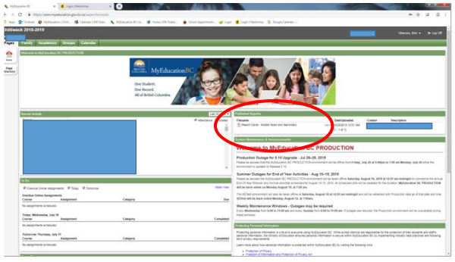
☐ Once Learning Updates have been posted, you will receive an email notification. You can view your students Learning Update or Learning Summary under “Published Reports” which is located on the main landing page. (See example below).
Finding Student Report Cards

On a mobile device, the full functionality of MyEducation BC is available on a mobile device by switching to the Full Site interface. From the Home Page, scroll down and click the View Full Site button.
Questions?? For questions or concerns, please email iss-alloffice@sd33.bc.ca

