2023/24 annual messaging toolkit
Last update: July 2023
Healthy schools

Contents
About this toolkit 3
Topics by month 4
September – Back to school health 5
October – Child health screenings: vision, hearing and dental 7
November - Respiratory season and fall immunizations 9
December – Winter health 11
January – Mental health 13
February – Anti-bullying, cyberbullying and digital literacy 15
March – Spring health 17
April – Outside play, physical activity and injury prevention 19
May – Mental Health and Youth Substance Use 21
June – Summer health 23

About this toolkit
Help your school community stay healthy and well throughout the school season.
This annual messaging toolkit is intended to provide schools with content to help educate parents or caregivers and students on important health topics.
There is written and visual content, organized by month of the school year, provided below that can be used on your school’s website, newsletters, social media or emails. You’ll find complete articles and social media posts that you can copy and paste directly onto your platforms.
If you have questions, concerns or feedback, please contact your school health nurse.

Topics by month

Month | Topic
September | Back to school health
October | Vision, hearing and dental screenings
November | Respiratory season and fall immunizations
December | Winter health
January | Mental health awareness
February | Anti-bullying, cyberbullying and digital literacy
March | Spring health
April | Outside play and physical activity
May | Mental health and youth substance use
June | Summer health

September – Back to school health
Article for website or newsletter:
Your healthy back-to-school guide
As summer winds down, it’s time to gear up for a healthy back-to-school season. Set the stage for a smooth transition back to school. Here are some practical tips to get you started.
Prioritize sleep
Ensuring your child gets enough sleep is an important part of a healthy back-to-school routine. Quality sleep helps with concentration, mood and overall well-being. In the weeks leading up to the start of school, gradually adjust your child’s sleep schedule so they can adapt to the new routine. Aim for nine to 11 hours of quality sleep per night.
Eat well
Support your child’s learning and development with scheduled meals and snacks. Breakfast kick starts their morning, while snacks and lunches nourish them throughout the day. Pack a water bottle to help them stay hydrated.
Boost immunity
As with any public environment, school exposes children to various germs and viruses. Ensuring they are up-to-date on their vaccinations helps protect them and others. Specific immunizations are recommended for children prior to entering Kindergarten as well as in grades six and nine. Help your child avoid the spread of illness by encouraging them to wash their hands regularly, teaching them to cover their coughs and sneezes and keeping them home when sick.
Keep active
Adding physical activity to your child’s routine sets them up for success. Activities like walking or biking to school, playing sports, dancing, swimming or helping around the house are great ways for your child to stay active. Set limits on screen time and promote outdoor play as much as possible for overall well-being.
Make time for talking and connection
Going back to school can be a cause of anxiety or stress for children. Make it a point to encourage open communication and support your child to talk about their feelings and help them feel heard and understood. Integrate downtime into their routine where they can relax or focus on a special interest or hobby.
Find more school health tips and resources on Fraser Health’s website: https://ow.ly/gS1S50Pegic

Social media posts
Facebook
Plan for a smooth transition back to school with tips from Fraser Health’s healthy back-to-school guide: https://ow.ly/SWgx50PegMV.

Twitter
Need help gearing up for back-to-school season? Check out Fraser Health’s healthy back-to-school guide for tips and resources: https://ow.ly/7oh450PegY3.

Instagram
Check out Fraser Health’s healthy back-to-school guide for everything you need to know about keeping your child healthy this back-to-school season: https://ow.ly/wZhk50PegX8.

Image to use with article or social media posts:
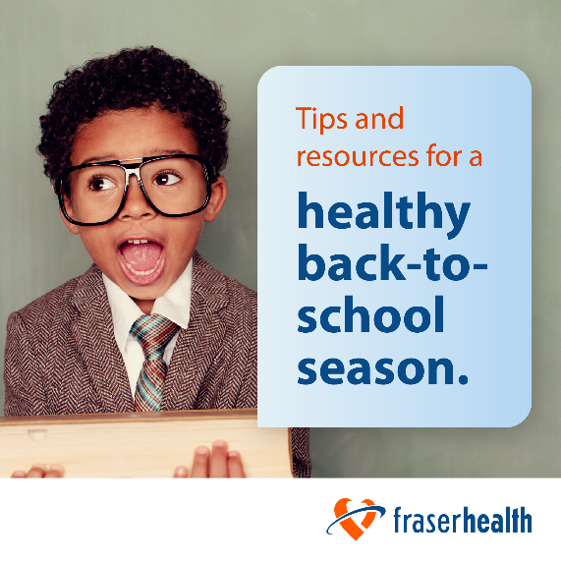

October – Child health screenings: vision, hearing and dental

Article for website or newsletter:
Make dental, hearing and vision checks part of a healthy routine
Health screenings help find issues early which can make treatment easier and more effective. It’s important for your child to have regular eye exams and routine dental checkups. It is also important to recognize any hearing loss early as this is essential for speech and language development. Read on to learn when and how to access services for your child.
Dental
Tooth decay is the most common, but preventable, childhood chronic disease. It is important to establish good oral hygiene at a young age and have children’s teeth checked by a dentist regularly. To find a local dentist near you who is accepting new patients, visit the BC Dental Association's Find a Dentist database. If you are a member of a low-income family and you do not have extended health coverage, there are several programs that can help you access affordable dentistry for your children. You can also contact the dental program at your local public health unit and ask about resources available in your community.
Vision
BC Doctors of Optometry recommends children receive their first eye exam when they are six to nine months old with a follow up exam at least once between the ages of two and five and then yearly once they enter school. You can find an optometrist accepting new patients near you at the College of Optometrists of British Columbia's Find an Optometrist database. In B.C., basic eye exams, one per year, are free up to the age of 18. Some optometrists may charge a small user fee of about $35 per visit so be sure to ask about any fees before you make an appointment.
Hearing
Good hearing is essential for speech and language development and plays an important part in a child's social and emotional growth. It is important to recognize hearing loss early and seek out testing and treatment if needed. Fraser Health’s Public Health community audiologists provide hearing services for children from birth to 19 years of age. If you have a concern about your child's hearing, referrals can be made by a parent or caregiver, a health care provider or education professional to your local public health audiology (hearing) clinic.
Find more information on child health screenings and how to access free vision, hearing and dental exams on Fraser Health’s website: https://ow.ly/oK9z50PegZB

Social media posts:
Facebook
Regular dental, hearing and vision exams are important for your child’s development. Learn when and how to access these services for your child on Fraser Health’s website at: https://ow.ly/xrqR50Peh1u.

Twitter
Health screenings such as dental checkups and eye exams can help find issues early, making treatment easier and more effective. Learn how to access dental, hearing and vision exams for your child on Fraser Health’s website: https://ow.ly/jtS050Peh4Z.

Instagram
Ensure your child is getting the most out of their education with regular dental, hearing and vision checkups. Learn what to look for and when to book checkups on Fraser Health’s website: https://ow.ly/EIyz50Peh4a.

Image to use with article or social media posts:
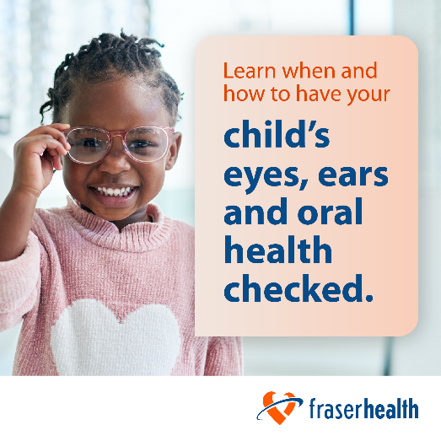

November - Respiratory season and fall immunizations

Article for website or newsletter:
Protect your children from respiratory illnesses this winter
Respiratory illnesses tend to increase as we spend more time indoors. Common colds, the flu and COVID-19 spread through tiny droplets as people who are sick breathe, talk, cough or sneeze. When other people touch these droplets and then their eyes, mouth or nose before washing their hands, they may become sick.
There are a handful of steps both children and adults can take to protect themselves and limit the spread of respiratory illnesses:
- Wash your hands often with soap and water. Use alcohol-based sanitizer if soap and water is not available.
- Avoid touching your face, especially your eyes, mouth and nose.
- Cough and sneeze into your elbow.
- If you have symptoms, stay home and stay away from people at higher risk of serious illness.
Flu and COVID-19 vaccinations
The best way to protect others and reduce the risk of getting the flu and COVID-19 is to get immunized. The flu and COVID-19 vaccines are safe, free and available to anyone aged six months and older.
It is much safer to get the vaccines than to get the illnesses. Register your children with the Get Vaccinated system so that you can be invited to book their vaccinations when they are due.
Learn more here: https://ow.ly/OHq450Peh5O

Social media posts:
Facebook
Anyone aged six months and older is eligible for both the flu vaccine and the COVID-19 vaccine. Protect your child this respiratory season by getting vaccinated. Find more information about immunizations on Fraser Health’s website: https://ow.ly/hM5i50Peh7L.

Twitter
Protect yourself and your child from respiratory illness this winter by getting immunized with the recommended vaccines. Learn more about immunizations on Fraser Health’s website: https://ow.ly/M0Jk50Peh9y.

Instagram
Ensuring your child is up-to-date on their vaccinations helps protect them and others.
Visit Fraser Health’s website to learn more about immunizations and how to book appointments: https://ow.ly/RbLx50Peh8P.

Image to use with article or social media posts:
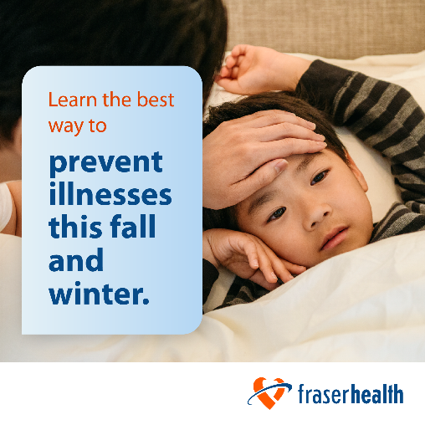

December – Winter health

Article for website or newsletter:
Keeping your child healthy during winter
As the chilly winter season is upon us, there’s a few extra things you can do to help keep your children healthy and well. Navigate this season with these essential tips.
Bundle up for the cold
Dressing appropriately for the cold weather is vital in keeping your child comfortable and protected. Wearing multiple layers is a great way to trap body heat and provide insulation against the cold.
Keep a warm hat, gloves, scarves and insulated boots handy. Remind your child to wear these items before heading outside to play or going to school.
Protect against winter illnesses
Winter brings an increased risk of colds and flus. Make sure your child is getting enough sleep (nine to 11 hours for elementary-aged children), eating a variety of foods and staying hydrated by drinking plenty of water. Ensure your child receives their annual flu vaccine and talk to a health care provider about any additional vaccines that may be recommended. Teach your child good respiratory etiquette such as regular hand washing, covering their coughs and sneezes and staying home when sick.
Keep their bodies moving
While colder weather may limit outdoor activities, it’s crucial to keep your child active during winter as regular physical activity boosts their immune system and keeps them energized. Encourage indoor play and activities such as dancing, yoga or interactive video games that promote movement. Look for winter programs at local community centres or indoor sports facilities.
Find more tips for a healthy winter: https://ow.ly/77AK50Pehvi

Social media posts:
Facebook
Keep you and your child healthy this winter by following Fraser Health’s winter health tips: https://ow.ly/h3Hq50PehwB.

Twitter
Learn how to keep warm, protect against illnesses and stay active this winter with Fraser Health’s Healthy Winter Guide: https://ow.ly/8ybj50PehAl.

Instagram
Indoor activities like dancing and yoga can keep you and your child active this winter. For more winter health tips see Fraser Health’s Winter Health Guide. https://ow.ly/LUTi50Pehy6.

Image to use with article or social media posts:

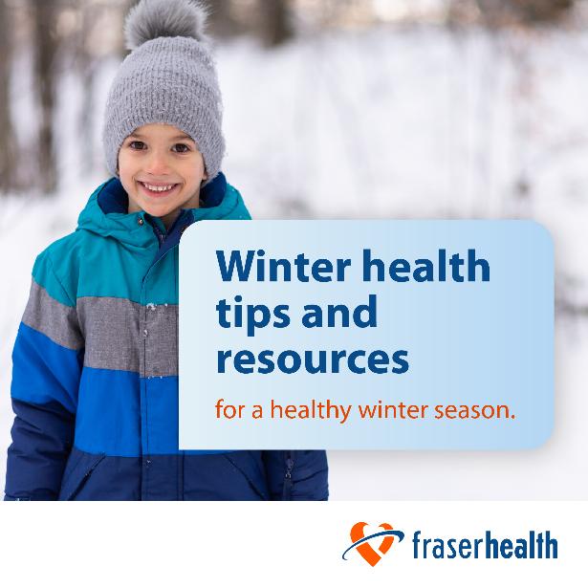

January – Mental health

Article for website or newsletter:
Know when and how to access mental health support for your child
Mental illnesses are common in children and young people, they can have a significant impact on their development, relationships and their performance in school. Getting help early can prevent symptoms from becoming more severe and support a faster recovery.
Where do I start if my child or teen needs help?
A good place to start is by talking with your child/teen about how things have been going for them and what you’ve noticed.
Keep in mind that children and teens vary in their ability to talk about their feelings and experiences. They may not have the vocabulary to describe feelings. They also may not understand what’s going on for them or make the connections between something in their life and their struggles.
How do I talk to my child or teen?
Here are some tips to help start a conversation with your child:
- Find a good time and place to talk. Driving to and from places, preparing dinner, or cleaning up after a meal are great opportunities to talk.
- Ask how they are or if they’d like to talk about anything that’s going on for them.
- If they say they’re fine or nothing is wrong, explain why you’re concerned and offer specific examples that you’ve noticed.
- Acknowledge how it must be difficult for them.
- Ask about what strategies/actions they find helpful. Acknowledge their strengths.
- Discuss how mental health is part of everyone’s life – and not just about severe problems.
- Talk about how sometimes it can take the assistance of others to overcome difficulties. Ask if they would they like to talk with someone.
- Ask them what they think would help or what they think they need.
- Offer to make an appointment for your child/teen to see your family doctor – physical issues can sometimes have mental health symptoms associated with them. It’s important to check if there’s any physical issues.
- Let them know you want to help and that they can always come to you.
- If your child doesn’t want to talk, let it go and try again in a few days.
- If you have concerns that your child may using alcohol or other drugs, get tips on how to talk to your child about drugs.
Get more information about child and youth metal health: https://ow.ly/KgZZ50PehL0

Social media posts:
Facebook
Mental illnesses are common in children and young people, but getting help early can support a faster recovery. For mental health help and resource for children and youth, visit Fraser Health’s website https://ow.ly/TCtH50PehC6.

Twitter
Need help talking to your child about mental health? Visit Fraser Health’s website for tips to help start a conversation with your child: https://ow.ly/ePnc50PehX9.

Instagram
Fraser Health has resources to help you learn the signs and symptoms of mental health problems in children and teens and tips for starting conversations. Visit their website to learn more: https://ow.ly/qXKf50PehW8.

Image to use with article or social media posts:
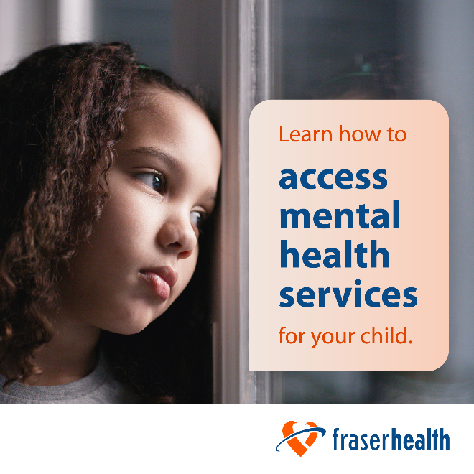

February – Anti-bullying, cyberbullying and digital literacy

Article for website or newsletter:
Help keep kids stay safe from bully behaviour online and at school
Bullying can affect all children and has negative impacts on the victim as well as the bully.
Bullying can appear in several forms:
- Verbal bullying: Examples are name calling, making fun of someone, making jokes at another's expense, unwelcome teasing and spreading secrets someone disclosed in confidence.
- Physical bullying: Pushing, shoving, pinching, hitting, spitting, damaging property and vandalizing lockers or school supplies.
- Social bullying: Examples are spreading rumours, being exclusive with friends and excluding people from events or study groups.
- Cyberbullying: Using social media to intimidate, exclude and disseminate private information or using texting, emails or other applications to damage someone's reputation.
Strategies focused on building self-esteem, developing respectful relationships and providing clear but respectful communication tend to be the most successful.
Children who are bullied need to be empowered and supported in developing healthy relationships.
Bullies on the other hand, need to learn social responsibility, empathy, right from wrong and remedial actions, such as rebuilding relationships and apologizing.
What can you do as a parent to prevent or deal with bullying?
- Encourage your child to report bullying they either experience or witness to school staff, such as teachers, counsellors, principals or parents.
- Provide opportunities for open dialogue about sensitive topics.
- If your child is the bully, encourage them to reflect on their actions, and how they would feel if the tables were turned and they were on the receiving end.
- Help your children develop digital literacy so they are aware of what cyberbullying looks like and have strategies for handling cyberbullying when it arises.
Find more advice for preventing or dealing with bullying on Fraser Health's website at: https://ow.ly/Yq2150Pei4C

Social media posts:
Facebook
Bullying can affect all kids. For resources on preventing or handling bullying, visit Fraser Health’s website: https://ow.ly/TARu50Pei6G.

Twitter
Fraser health has tips on preventing and dealing with bullying. Learn more at https://ow.ly/LSZ750Pez9y.

Instagram
Help your child learn and understand what bully behaviour is and how it can affect themselves and others, see https://ow.ly/98yR50Pez95.

Image to use with article or social media posts:

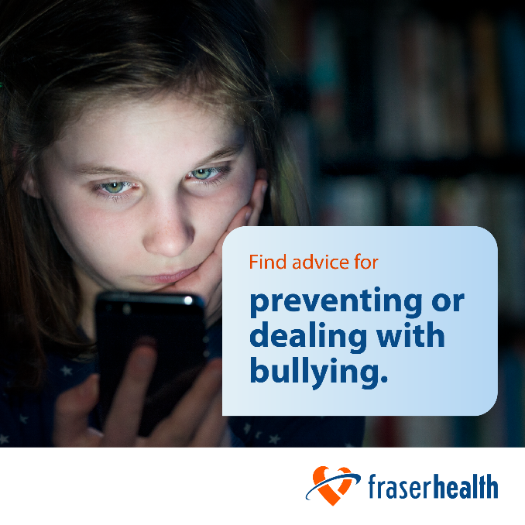

March – Spring health

Article for website or newsletter:
Spring health for kids
The spring season is approaching which means warmer weather and more outdoor activities. It’s also an opportunity to foster new healthy habits for our children. Here are five practical tips for school-aged kids to make the most of this season.
Get active
Warmer weather makes spring the perfect time to get outside and play. Take a walk around your neighbourhood or head to a local park or hiking trail. You can also stay active close to home with some backyard jump rope or hopscotch.
Think fresh
Springtime often brings up images of fresh fruits and produce. Now is a great time to teach children about where food comes by helping them to start their own home garden. You don’t need a large space to get started. Strawberries, tomatoes and lettuce can all be grown from pots on a sundeck.
Be sun safe
Sun burns are possible even in spring. Use a sunscreen that has Sun Protection Factor (SPF) 30 or more. When possible, schedule outdoor activities in the morning or late afternoon and early evening. If you and your children are out in the sun during mid-day hours, wear long sleeves, loose-fitting long pants and a hat with a wide brim.
Support positive mental health
The best way to support positive mental health in your children is by forming strong and caring relationships with them. Make time for connection each day. Talk to them about their feelings and experiences.
Practice road safety
Biking is a great way to exercise and spend quality time with your family. Remember to keep safety top of mind. Protect their heads with a well-fitted helmet and teach them the rules of the road, such as the hand signals for stop, right and left-hand turns.
Find more tips for a healthy spring in Fraser Health’s Spring Health Guide: https://ow.ly/HR5150Pez9Y

Social media posts:
Facebook
As the spring season approaches, help your child start their own home garden to teach them where food comes from. For more tips for a healthy spring in Fraser Health’s Spring Health Guide: https://ow.ly/I8pw50Pezal.

Twitter
Spring time means more fun outdoor activities for children, like riding bikes and scooters. It’s a good time to remind your child about road safety and how to protect themselves. Learn more about spring safety in Fraser Health’s Spring Health Guide: https://ow.ly/IYzt50PezaW.

Instagram
Get active this spring season by taking a walk around the neighborhood or on a hiking trail. For more spring health tips in Fraser Health’s Spring Health Guide: https://ow.ly/6uQ450PezaM.

Image to use with article or social media posts:
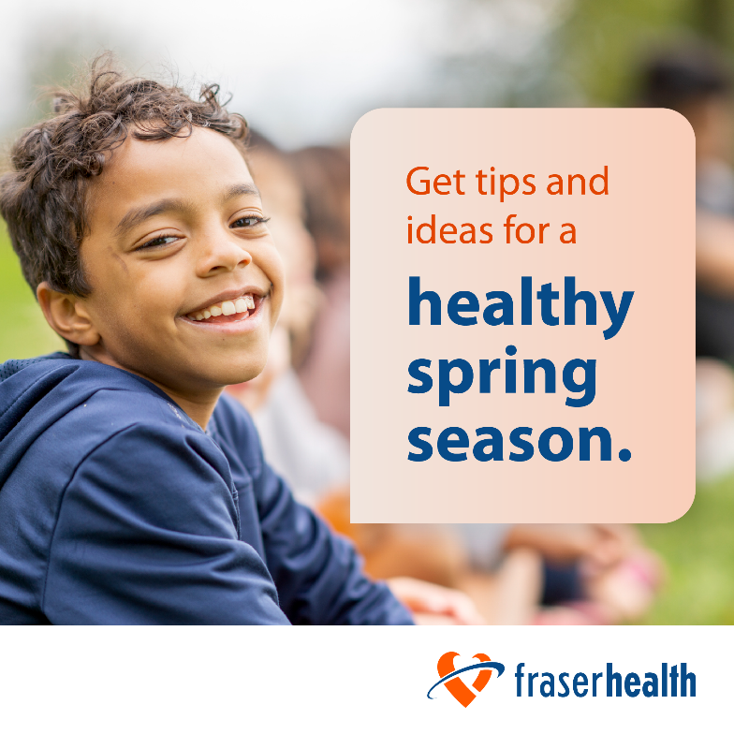

April – Outside play, physical activity and injury prevention

Article for website or newsletter:
Get outside and play
Physical activity is a necessary requirement for optimal health – and the benefits are even greater if you can do it outdoors.
Regular physical activity in childhood helps to develop cardiovascular fitness, muscle strength and bone density, and being outdoors is known to improve mental health.
There are many benefits to unstructured, outside play. When children spend time outside, they:
- Sit less, move more and play longer – key to cardiovascular health and fitness.
- Have healthier eyes – 10+ hours a week outside reduces nearsightedness risks.
- Sleep better – sunlight helps regulate melatonin and sleep patterns.
- Enjoy improved mood – exercise reduces symptoms of anxiety and depression.
- Feel more connected to nature – experience calm and develop mindfulness.
Planning active outings doesn’t have to be challenging or costly. Here are some ideas that you can try this week:
- Go for a walk or hike – try these 10 hikes to take your kids on this summer.
- Play in a forest or park – try a new regional park every day for a week.
- Climb a tree – this Vancouver climbing tree is inspiring, but start smaller!
- Explore a local stream – check these beautiful watershed walks in the region.
- Play hopscotch or jump rope – try teaching these six fun jump rope games.
- Swim at the pool, waterpark or beach – check beach safety conditions first.
- Ride a bike or scooter – find easy, family-friendly cycling routes.
- Visit farms, fish hatcheries and bird sanctuaries – this local family fun guide has unique ideas.
Find more ideas to keep your kids active through the year on Fraser Health’s website: https://ow.ly/lrmm50PezbK

Social media posts
Facebook
Physical activity is a necessary requirement for optimal health in children. Visit Fraser Health’s website to learn about the importance of physical activity and how to incorporate it into your child’s daily activities: https://ow.ly/e3Zq50Pezc4.

Twitter
Visit Fraser Health’s website to find out how much physical activity is recommended for your child as well as tips to support your child to be physically active: https://ow.ly/VFMv50PezeJ.

Instagram
There are many benefits for children who play outside, like cardiovascular health, better sleep and improved mood. Fraser Health’s guide to outdoor play can help you plan outdoor activities even when you’re on a tight schedule: https://ow.ly/x2E850Pezcn.

Image to use with article or social media posts:
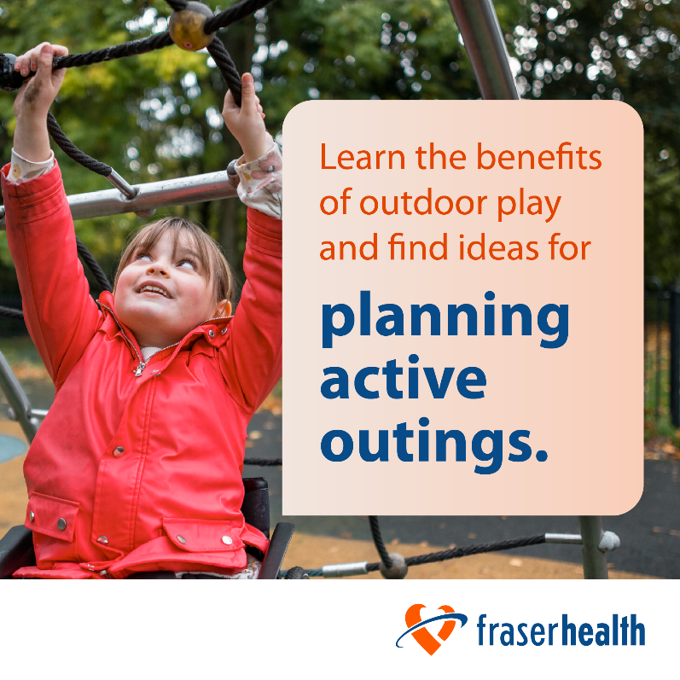

May – Mental health and youth substance use

Article for website or newsletter:
Mental health and substance use impacts on youth
Youth is a time of growing, learning and changing. It can also be a time when behaviours may become more risky and youth may experiment with substance use. Alcohol, vapour products and cannabis are the most common substances used by youth.
Cannabis, alcohol and the nicotine found in vaping products, can have negative impacts on the way a child or youth’s brain grows and develops. This puts youth who use substances at increased risk of mental health issues, such as depression, anxiety and psychosis. Helping youth to avoid or delay substance use for as long as possible can help protect their mental health and brain development.
For youth who are already using substances, the earlier we help the better. Here are some tips to help you support your child or youth:
- Start by having open and honest conversations. Avoid lecturing or judgements.
- Seek out factual information to share with your children.
- If you use alcohol or other substances, pay attention to when, why and how much you use. Have conversations with your children about how they feel about your alcohol or substance use.
- Encourage youth to delay the decision to use alcohol and other substances. Have conversations with them to see if they are thinking about trying alcohol or other substances. If they are, ask if they could wait one year? Then, a year later, maybe ask if they could wait another year.
- Let youth know that not everyone chooses to use alcohol or substances. Alcohol is carcinogenic and contributes to significant health and social harm.
- Have clear, but caring boundaries and family guidelines about alcohol and substance use. Ensure your child feels safe and supported. For example, let them know you will be there for them to provide a safe ride home for them or their friends if they need one.
Visit Fraser Health’s website to learn more about substance use in children and youth at: https://ow.ly/KqgY50Pezjh

Social media posts:
Facebook
Are you concerned about your child’s mental health, substance use or both? Fraser Health offers services, programs and resources to help your child. Learn more here: https://ow.ly/gBwh50Pezkc.

Twitter
Need help understanding substance use, such as drugs, tobacco, vaping products and alcohol, in school-aged children? Visit Fraser Health’s website for programs, resources and services: https://ow.ly/4Jqz50Peznm.

Instagram
Mental health and substance use can be a tough topic to approach with your child. Visit Fraser Health’s website to learn how to talk about these topics and what resources are available: https://ow.ly/yQcg50Pezm4.

Image to use with article or social media posts:
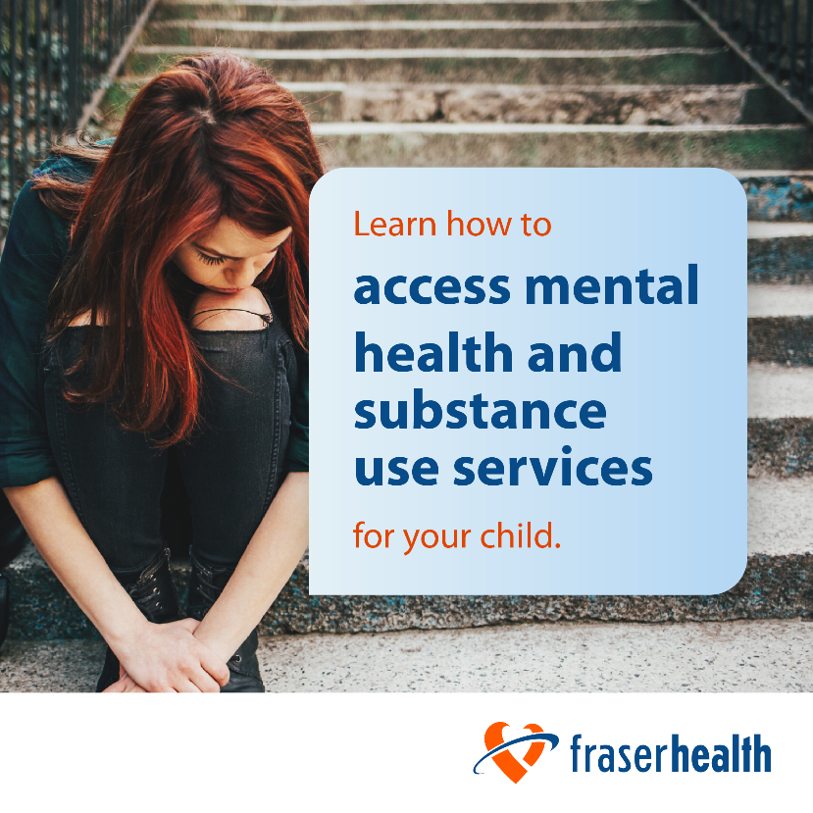

June – Summer health

Article for website or newsletter:
Keeping kids healthy and safe this summer – tips for parents
As summer approaches, excitement levels rise in anticipation for outdoor adventures, sports and family vacations. Summer is a time for fun and relaxation, but it’s also a time to prioritize health and well-being. Below are some tips to help your kids stay active, healthy and safe during the summer months.
Sun protection
Help avoid sunburns by applying a sunscreen lotion with Sun Protection Factor (SPF) 30 or more to your children (and yourself) at least 20 minutes before heading outside. Seek shade and stay out of the hot sun between 11 a.m. and 4 p.m. Look for places with lots of shade, such as parks with big trees. Take an umbrella or tent to the beach and cover up with a wide brimmed hat, long sleeves and lose-fitting long pants.
Breathe easier
B.C. wildfires and dry weather conditions are common during the summer months resulting in poorer air quality. Reducing exposure to wildfire smoke is the best way to protect your and your family’s health. Stay on top of air quality advisories.
Hydration
Encourage your children to drink water regularly, before they become thirsty. Instill the habit of always carrying a water bottle with them wherever they go.
Physical activity
Parents who join in on soccer games, splash in the pool or set out on hikes with their children on summer vacation – and all year long – not only get fit themselves but provide healthy role models for the next generation. Healthy, active outdoor play is one of the best ways to improve both adults’ and children’s overall physical and mental health.
Enjoy the bounty of the summer produce
Summer is here, which means fresh fruits and vegetables are in season. This makes it an ideal time to eat some delicious locally grown foods. Local farmers’ markets and u-pick farms are a fun way to enjoy farm fresh fruits and veggies while getting outside and supporting your local farmers.
Find more summer health tips in Fraser Health’s Healthy Summer Guide: https://ow.ly/KqgY50Pezjh

Social media posts:
Facebook
Prioritize your health and well-being with Fraser Health’s summer health tips. For tips on staying active and healthy this summer visit https://ow.ly/C83H50Pezh3.

Twitter
Keep you and your child hydrated this summer by carrying a water bottle with you. For more tips, see Fraser Health’s Summer Health Guide: https://ow.ly/oY8550PezhG.

Instagram
Fraser Health has put together tips and resources to help you and your children stay active, healthy and safe during this summer break. Check out their Summer Health Guide at: https://ow.ly/CyO750Peziv.

Image to use with article or social media posts:

