Information for Parents and Caregivers

K-12 Student Reporting

When you were in school, were you asked to memorize information and repeat it on a test, only to forget it soon after? We now know learning is not just memorizing – it’s being able to use what we know and apply it in real-world settings.
Universities, colleges, and employers today care more about how students think than how many facts they can repeat.

BC’s Curriculum
The learning students do today is more complex than ever. British Columbia redesigned the provincial curriculum to respond to the needs of today’s learners. The curriculum continues to give your child a strong foundation in reading,
writing, and math. But it also teaches your child how to think critically, communicate, solve problems, and use their knowledge in ways that both matter in school and will matter in a rapidly changing future.
The new curriculum has been in place in all grades since 2019, but report cards and the way student learning is communicated haven’t really changed for decades. Report cards are now changing to align with the curriculum and to help ensure that every student in the province is set up for success in their learning.

Classroom assessment
You may remember getting a letter grade or percentage at the end of a chapter in your textbook or after a test, signaling to you that learning had come to an end. Today we know that learning doesn’t stop when students hand in an assignment or complete a test.

We also know that:
- student learning can be communicated in ways other than letter grades
- teacher feedback on student learning can help students continue to learn
- students are more engaged when they have a say in how they show their learning

That’s why students will receive marks on a four- point scale from Kindergarten to Grade 9. Students in Grades 10-12 will still receive a letter grade and percentage to support their entry into post- secondary education. And reporting for all students will now include self-reflection and goal setting.

Report Cards
These changes mean that report cards might not look the same as when you were in school. But the information you will now receive will provide a complete picture of what your child can do, where they need to improve, and how you can support their learning. Reporting in this way will ensure that students focus on learning instead of competing for marks.

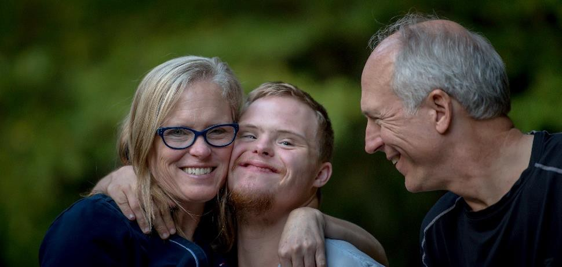
For more information:
What is consistent? | What is evolving?
5 reporting events (3 written and 2 informal reports, such as parent/caregiver-teacher conferences) | Inclusion of the graduation status update at grades 10-12 on the end of year report card
Letter grades and percentages at grades 10-12 | The consistent use of the Provincial Proficiency Scale by all districts at grades K-9
Written feedback grades K-9 | Written feedback at grades K-12
Student self-assessment of Core Competencies grades K-9 | Student self-assessment of Core Competencies and goal-setting grades K-12

The Provincial Proficiency Scale
If your child is in Grades K-9, you won’t see letter grades on their report card. Instead, you will see information on where your child is on the Provincial Proficiency Scale. The scale uses the terms “Emerging,” “Developing,” “Proficient,” and “Extending” to describe student learning. The scale maintains high standards for student learning.

Emerging | Developing | Proficient | Extending
Emerging means your child is beginning to understand something in an area of learning. They are still learning but may need more support to move ahead.  Emerging doesn’t mean your child is  unsuccessful in this area. | Developing means your child understands some things in an area of learning but still has other areas to work on. Like Emerging, it doesn’t mean your child is unsuccessful in this area. | Proficient is the goal for your child. It's also the goal for all students. When your child is Proficient, it means they fully understand the required learning. But it doesn't mean their learning  stops. | Extending is when students show a deeper understanding. It’s when your child is able to apply their learning in new and different ways.  Extending is not the goal for all students in every area of learning.

